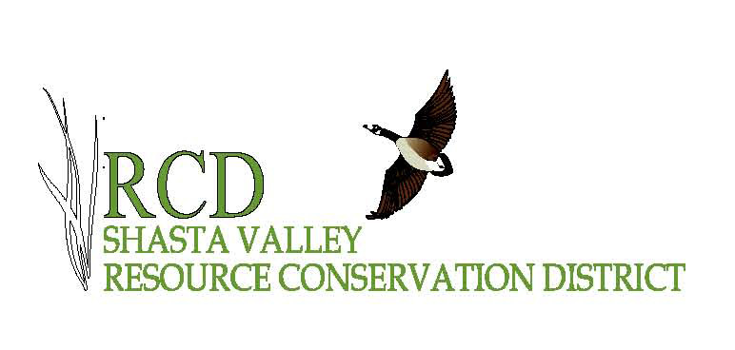
SHASTA VALLEY RESOURCE CONSERVATION DISTRICT
Siskiyou County, California

Summarized MINUTES from the Board of Directors' Regular monthly meeting of the Shasta Valley Resource Conservation District, in Yreka, California, on Wednesday, November 9th, 2022.

Directors Present: Ryan Walker, Mike Duchi, Mike Luiz, Bill Hirt (late), Zack Salvestro (late)
Directors Absent: None
Associate Directors: None
Staff Present: Ayn Perry, Rod Dowse
Guests in attendance: Alisa Scholberg (contract book keeper); Jim Patterson, NRCS,

This meeting was conducted as a hybrid in-person/remote meeting. The location for the meeting was the Siskiyou Economic Development Council conference room, 1512 S. Oregon Street; Yreka, CA.

Call to Order
After a quorum was established, the meeting was called to order at 6:31 pm by Chair Walker.

Review and Approval of Agenda
The agenda was approved by common consent.

Introductions None needed.

Public Comment: None.

Presentation None

Approval of Minutes
ACTION: Approve Minutes for October 12th, 2022. MOTION: Luiz, SECOND: Duchi. Approved by Voice Vote: AYES: Duchi, Luiz, Walker, Noes: None Abstentions: None Motion Approved
Financial Report
Scholberg presented the SVRCD Financial Report for review and action. She reported that as of November 10 2022, the SVRCD has Accounts Receivable of $268,671.51. Assets of $718,832.41, Liabilities $255,649.97, Ordinary Income of $70,263.84, Interfund Cash of $393,405.86. ACTION: Approve Financial Report. MOTION: Duchi, SECOND Luiz; Approved by Voice Vote: AYES: Duchi, Hirt, Luiz, Walker, Salvestro, NOES: None; ABSTENTIONS: None. Motion Approved.
Ratify Payroll
Scholberg reviewed the payroll for October in the amount of $29,362.60. ACTION: Approve Payroll. MOTION: Luiz, SECOND: Duchi, Approved by Voice Vote: AYES: Duchi, Walker, Hirt, Luiz, Salvestro, NOES: None; ABSTENTIONS: None. Motion Approved.

Approval of Bills
Scholberg presented the October bills for review and approval. Warrants for $86,607.15 submitted for approval. ACTION: Approve Bills for Payment. MOTION: Duchi, SECOND: Luiz; Approved by Voice Vote: AYES: Duchi, Walker, Luiz, Hirt, Salvestro, NOES: None; ABSTENTIONS: None. Motion Approved.

Overhead: $2,417.26
US Bank $380.35
US Bank $80.41
Alisa Scholberg Bkkpg $1,812.50
Cal Ore Comm $104.00
Streamline $10.00
Sean Evangelista $30.00

Grant Invoices: $82,996.10
Oregon State University $47,526.10
Sacramento River Water $35,110.00
Siskiyou Cty Develop $360.00

Employee Reimbursements: $1,193.80

Budget Transfers: None
Approval of Donations Received: None
Correspondence: None

Business – Discussion and Possible Action

10.1 Continued review and input on draft SVRCD Logo. Tabled
10.2 Review and accept 2021-2022 Audit SVRCD Fiscal Audit. Dowse informed the Board about the successful completion of the Audit. A regular annual audit and a federal single audit were both completed together. With one small correction, the books passed with flying colors.
10.3 Resolution 22-010 IRWM NCRP – Affirming our adoption of the North Coast Integrated Regional Water Management Plan. Dowse explained that this is required by NCRP for our recently submitted grant application. SVRCD has previously (2014) adopted this resolution. ACTION: Approve Resolution 22-010. MOTION: Luiz, SECOND: Duchi; Approved by Voice Vote: AYES: Duchi, Walker, Luiz, Hirt, Salvestro, NOES: None; ABSTENTIONS: None. Motion Approved.

Staff and Project Reports
Dowse gave various updates regarding staffing. Allen Lagrange resigned to take another job.
Forestry projects were shared via a written report to the Board, (attached).

Board members Reports: Luiz requested information on our new resiliency grant. There was discussion on agency staff changes within CDFW. Joe Croteau has retired.

Agency Reports: Patterson gave an update on NRCS. Without a forester on staff, the program keeps getting further behind. He is attending the CARCD meeting in Folsom, this month. There was discussion on how the SVRCD can support NRCS with funding for projects that EQIP or FSA programs are not responding to. Drought requests for emergency assistance (example stock water) do not always receive priority funding from agencies in a timely manner.

Closed Session: The Board went into Closed Session at 7:16 Left closed session at 7:36. Resumes were reviewed and decision was made Moved by Walker Second by Hirt Ayes Duchi, Walker, Hirt, Salvestro, Noes: None, Abstention: Luiz

Meeting Adjourned –
The meeting was adjourned at 7:40 by Chairman Walker.

Agenda Items Pending, Held Over:
Long Range Plan/Board Fall Retreat
Logo decision
Invite Morgan Knechtle, CDFW to a meeting to discuss partnership opportunities.
Invite Chrystal Robinson CDFW to a meeting

Minutes submitted by Ayn Perry on 11/14/2022

Minutes approved as typed as corrected.

__________________________________
Chairman

__________________________________
Date

__________________________________
District Administrator

