McKinney Fire Burned Area Recovery

Project Summary
The Shasta Valley Resource Conservation District is managing a project to fall streamside dead, standing trees on Shasta Trinity National Forest land in the McKinney Fire (2022) burn area.
Purpose: The McKinney Burned Area Recovery Habitat Restoration project will accelerate recovery of riparian conditions and accelerate recovery of south facing upland soils within the McKinney Fire (2022) perimeter. The overall project purpose is to repair or improve General Forest (upland felling) and Riparian Reserve (stream channel felling) unlikely to recover naturally to a management approved condition. The instream tree felling will be used to reduce channel down-cutting, slow water velocity, trap sediment, and help maintain channel characteristics above coho critical habitat.

Contractor’s Obligations
The Bidder must analyze and respond to all sections of this Bid Packet providing sufficient information to allow the SVRCD to evaluate the bids. The Contractor, by submitting its bids, agrees that any costs incurred by the Contractor in responding to this Bid Packet are to be borne by the Contractor and may not be billed to the SVRCD.

The Bidder must complete and submit all attachments in Appendix I, in the order listed. If the SVRCD has any confusion or difficulty in retrieving the required information from a Contractor’s bid, it may result in the disqualification of such bid.

Bid Submission Requirements
The contractor should mail or hand deliver or EMAIL their sealed bid to the address listed below by 2pm on Monday, March 9th, 2025.
Shasta Valley RCD
215 Executive Ct., Suite A
Yreka, CA 96097

The envelope shall be plainly marked in the upper left-hand corner with the name and address of the bidder and shall bear the words “Bid for the McKinney BAR Habitat Restoration Instream Tree Felling”

Critical Dates
Pre-bid Site Visit
Contractors wishing to bid on this project may view the project by setting up a viewing with the Project Managers listed below. Pre-Bid tour is scheduled for March 2nd, Monday at 8:00 am. Meet at the McKinney Creek site 1 location, which is south of the intersection of McKinney Creek Road and Walker Road. Prepare to travel to sites all day.

Quin McDowell, Project Manager
Email: qmcdowell@svrcd.org
Phone: (530)-925-6687

Anna Froelich, Project Manager (Assisting)
Email: afroelich@svrcd.org
Phone: (530)-643-6030
Bid Due Date
Bids shall be received by the SVRCD on or before Monday March 9th, 2026 at 2:00 pm at the SVRCD address listed above. Late submissions will not be accepted. Bids may be emailed or hard copy.

Contractual Commitment of Bid
The contents of submitted bids will be considered obligations of the successful Contractor. No information should be submitted that is not intended to be incorporated into the bid and any contract which may result from such bid. If there is any inconsistency between the terms herein and any of the contract documents, the terms in the contract documents shall prevail.
Contract Dates

The Contractor shall not begin operations until the Notice to Proceed is issued. All work shall be completed by September 30, 2026.

Project Specifications
The contractor is expected to follow the project specifications, site plans, permit requirements, and all federal, state, and county laws and standards for this project.
Riparian Reserves streamside dead standing trees will be dropped into drainages to: Reduce channel down-cutting, Slow water velocity, Trap sediment, and Maintain channel characteristics
- 10 trees per 0.25-mile reach is an estimate of target trees per mile; and a guide not a set target.
- The goal is to treat all identified areas combined with a total of at least 400 trees to meet biomass in stream targets.
- For implementation, it is critical that trees are felled into the creeks, or at an upstream angle across the creek, rather than spanning. If the tree can only be felled in a manner where it would span the channel, cut to create contact with the stream.
- If hazard trees must be felled to safely access the target tree, follow the same logic regarding direction of felling. Hazard trees would be in addition to the 400-tree goal.
- Target priority is trees over 24 inches DBH.
- Secondary target is trees no smaller than 15 inches DBH.
- Cut at least 25% of trees, leaving approximately 3-feet stump above ground level to provide purchase for tree boles and slash to hold in place.
- In areas where there are already multiple down trees spanning the stream, you may be requested to cut logs so that they will fall correctly into stream.

Safety:
- Contractor must provide an approved health and safety plan prior to beginning any work.
- Contractor shall give notice and schedule before any work occurs.
- Contractor shall provide and post signage, close off roads where necessary, and ensure the work area is clear of any members of the public.
- Contractor shall be responsible for initiating, maintaining, and supervising all safety precautions and programs in connection with the performance of the work.
- During the contract performance, Contractor shall protect the lives and health of workers performing the work and other persons who may be affected by the work and prevent damage to property adjacent to the project.
- Contractor shall comply with all applicable laws, ordinances, rules, regulations, and orders of any public body having jurisdiction for the safety, of persons or property or to protect them from damage, injury, or loss; and shall erect and maintain all necessary safeguards for such safety and protection.

Protection of Resources:
- Contractor will meet all requirements set forth by Federal and State regulations for protection of wildlife, botanical, and archaeological resources.

Boundaries:
Project boundaries are shown within the Klamath National Forest on the attached map.
Work progress:
Contractor’s operations shall progress in a workmanlike and orderly manner to avoid accidentally leaving untreated areas, with workers regularly connecting treated areas. At the end of each workday, no “islands” of untreated areas shall be left within areas that have been treated.

Payment Schedule
Contractor will be paid for expenses based on the invoices submitted monthly. The schedule is negotiable and will be refined during the contracting process. The SVRCD must receive invoices no later than the 5th of each month to adhere to the SVRCD’s billing schedule.
Payments to the contractors shall be paid within thirty (30) days of receipt of the funds by the SVRCD from the funding agency, which can be as much as three months after invoice submittal for this particular grant. SVRCD will make every effort to expedite payment to the contractor.

Additional Information
Site Locations: The project is located within the Klamath National Forest in the McKinney Fire area.
See maps in Appendix II for more information.
References & Required Experience: This project requires that the contractor has experience in logging and felling timber.

Insurance: The successful bidder will be required to provide SVRCD with proof of appropriate insurance.

Limited Operational Periods: Work within may have periods where operations cannot be done due to species of concern or weather conditions. Current LOPs may be lifted with appropriate surveys completed to protocol.
Labor Compliance: Contractor agrees to be bound by all the provisions of the California State Labor code.
Maps and Measurements: The maps are provided as Attachments. They are intended to show only the general size, shape, and location of the areas. If the maps conflict with field marking, the field markings shall govern. Positions of features are approximate. The units have been determined by Global Positioning Systems (GPS) and/or Geographic Information Systems (GIS).
Rework and Re-inspection after Rework:
When inspection indicates that the performance objectives were not met, the work will be deemed unsatisfactory rework will be required, unless the Project Manager determines that a reduction in pay in lieu of rework is acceptable. Re-inspection will be performed only when the Project Manager is notified by the contractor that the poor performance items have been corrected.
Safety:
Protection of Improvements and Survey Monuments: The Contractor shall avoid any damage to improvements such as, but not limited to: trails, telephone lines, pipelines, structures, roads, fences, gates, utility poles, power lines, pedestals, survey markers or monuments, and survey witness trees unless otherwise directed. The contractor will be required to repair or pay fair market value to replace any damaged improvements.
CERTIFICATION OF COMPLIANCE: Contractor shall certify compliance with specific fire precautionary measures included in the attached Fire Plan. The certification shall be made prior to commencement of work and shall be updated if at any time during performance the conditions change.

Road Maintenance
Roads shall be kept free of logs, slash and debris resulting from the Contractor’s operations. Trees or slash felled into roads must be immediately removed by Contractor. Any road used by the Contractor in connection with this work that is damaged through such use shall promptly be restored.
Endangered Species Act

Operating conditions and specifications shall be modified as required to comply with changes in the legal status of, or in the laws pertaining to protection measures for, any species under the federal or California Endangered Species Act. Such modifications shall be agreed upon mutually by the SVRCD and the Contractor.

Prevention of Oil Spills

If Contractor maintains storage facilities for oil or oil products on Project Area, Contractor shall take appropriate preventive measures to ensure that any spill of such oil or oil products does not enter any stream or other waters of the United States or any of the individual States.

Prevention of Damage to Trees

No unnecessary damage shall be done to regeneration, hardwoods, and leave trees. Trees specifically marked for leave, and all unmarked trees in watercourse and lake protection zones, shall be protected to the fullest extent feasible.

Attachments
Appendix I
- Bid Form Attachment No. 1: Contractor Information
- Bid Form Attachment No. 2: Proposed Sub-Contractors
- Bid Form Attachment No. 3: Bid Schedule
- Bid Form Attachment No. 4: Work Plan

Appendix II
- Exhibit A: Project Maps
- Exhibit B: Unit Information Table
- Exhibit C: Fire Plan
Appendix A
- Additional project requirements

Appendix I
BID FORM ATTACHMENT NO. 1: Contractor Information
General Information:

Company Name:
Company Address:
Contact Name:
Phone: |  | Fax:
Email: |  | Federal ID or SSN #:
Years in Business: |  | LTO  License #:

References: Provide 3 references, with contact names and phone numbers for each reference.

- (CONTACT NAME) ___________________________ (PHONE) ___________________

(BUSINESS NAME) ___________________________

- (CONTACT NAME) ____________________________ (PHONE) ___________________

(BUSINESS NAME) ____________________________

- (CONTACT NAME) ____________________________ (PHONE) ____________________

(BUSINESS NAME) ____________________________

Bid Information
Bidder agrees to accept as full payment the following total base bid price:

_____________________________________________ dollars

The bidder hereby acknowledges that the total base bid price is based solely on the bidder’s own estimate of costs and includes all applicable taxes, overheads, and profit.

Contractor Signature__________________________________________________________________

Additional bid Information: Please provide detailed information as outlined in the bid schedule below. Costs shown above should include all materials, labor, taxes, overheads, and profit, which must also be included in following schedule.

BID FORM ATTACHMENT NO. 2: PROPOSED Subcontractors

The BIDDER should submit with the Bid Form a listing of names and business addresses of subcontracting firms or businesses that will be awarded subcontractors for portions of Work as described above.
The Subcontractor list shall be completed and should include the following information:
- Subcontractors, listing each subcontractor whose subcontract amount is more than 10 percent of the Contract price with whom the bidder, if awarded the Contract, will subcontract for performance.
2. The categories of work those subcontractors will perform on the Contract.
A bid will be considered non-responsive and will be rejected if the BIDDER does not correctly complete the Subcontract List contained herein and include this Proposed Subcontractor list with the Bid Form.
- List of Subcontractors to be used
Subcontractor |  | Work |  |  | % of Total

BID FORM ATTACHMENT NO. 3: Bid Schedule

Task No. | DESCRIPTION (confirm based on plans and specifications) | QTY. | UNIT PRICE | TOTAL
1.0 | Felling streamside large woody debris as directed | 1 | hour
Total Bid Cost:

Units: hour = price per hour

For Tree Felling Task, bid price includes all costs to fell and buck trees as specified in the contract and directed by the SVRCD project managers.

BID FORM ATTACHMENT NO. 4: Work Plan

Please use the following space to describe in sufficient detail the work plan or methods you will employ to gain site access and accomplish the project according to specifications. This will include a full description of how the project will meet the site requirements and prevent damage to infrastructure. You may attach a written response to this packet if needed.

Appendix II

Attached: Map

Attached: FIRE PLAN FOR CONSTRUCTION AND SERVICE CONTRACTS – 2 pages

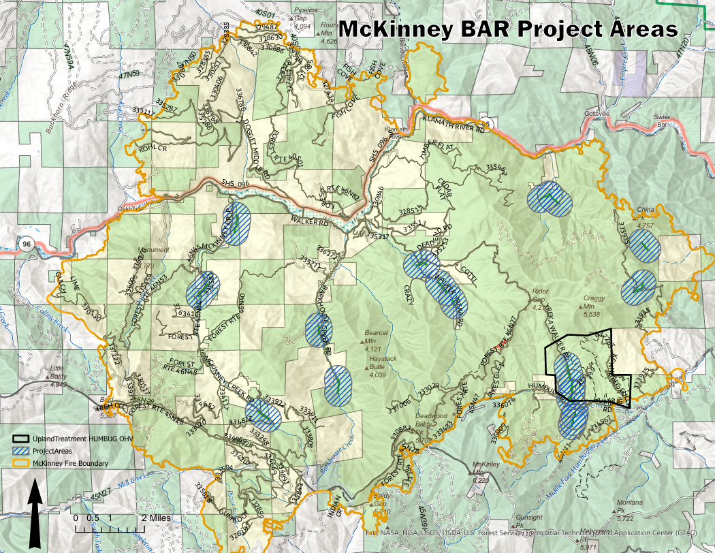
Exhibit A: Map of proposed actions for the McKinney BAR Habitat Restoration Project

FIRE PLAN FOR CONSTRUCTION AND SERVICE CONTRACTS
- SCOPE:
The provisions set forth below outline the responsibility for fire prevention and suppression activities and establish a suppression plan for fires within the contract area. The contract area is delineated by map in the contract. The provisions set forth below also specify conditions under which contract activities will be curtailed or shut down.
- RESPONSIBILITIES:

Contractor
Shall abide by the requirements of this Fire Plan.
Shall take all steps necessary to prevent his/her employees, subcontractors and their employees from setting fires not required in completion of the contract, shall be responsible for preventing the escape of fires set directly or indirectly as a result of contract operations, and shall extinguish all such fires which may escape.
Shall permit and assist in periodic testing and inspection of required fire equipment. Contractor shall certify compliance with specific fire precautionary measures in the fire plan, before beginning operations during Fire Precautionary Period and shall update such certification when operations change.
- TOOLS AND EQUIPMENT:

The Contractor shall comply with the following requirements during the fire precautionary period, as defined by unit administering contracts:

The Fire Precautionary Period is set by the State of California which is April 1 through December 1 of any year.
A. Fire Tools and Equipment: Contractor shall meet minimum requirements of Section 4428 of the California Public Resources Code (C.P.R.C.). Fire tools kept at each operating landing shall be sufficient to equip all employees in the felling, yarding, loading, chipping, and material processing operations associated with each landing. All required fire tools shall be maintained in suitable and serviceable condition for fire fighting purposes.
Trucks, tractors, skidders, pickups and other similar mobile equipment shall be equipped with and carry at all times a size 0 or larger shovel with an overall length of not less than 46 inches and a 2-1/2 pound axe or larger with an overall length of not less than 28 inches.
B. Fire Extinguishers: Contractor shall equip each internal combustion chipper with a fire extinguisher for oil and grease fires (4-A:60-B:C).
All Fire Extinguishers shall be mounted, readily accessible, properly maintained and fully charged.
C. Spark Arresters and Mufflers: Contractor shall equip each operating tractor and any other internal combustion engine with a spark arrester, except for motor vehicles equipped with a maintained muffler as defined in C.P.R.C. Section 4442 or tractors with exhaust-operated turbochargers. Spark Arresters shall be a model tested and approved as shown in the. National Wildfire Coordinating Group Spark Arrester Guide, Volumes 1 and 2, and shall be maintained in good operating condition. Every motor vehicle subject to registration shall at all times be equipped with an adequate exhaust system meeting the requirements of the California Vehicle Code.
D. Power Saws: Each power saw shall be equipped with a spark arrester approved according to C.P.R.C. Section 4442 or 4443 and shall be maintained in effective working order. An Underwriters Laboratories (UL) approved fire extinguisher containing a minimum 14 ounces of fire retardant shall be kept with each operating power saw. In addition, a size 0 or larger shovel with an overall length of not less than 38 inches shall be kept with each gas can but not more than 300 feet from each power saw when used off cleared landing areas.
- GENERAL
A. State Law: In addition to the requirements in this Fire Plan, the Contractor shall comply with all applicable laws of the State of California. In particular, see California Public Resource Codes.
B. Smoking: Smoking shall not be permitted during fire season, except in a barren area or in an area cleared to mineral soil at least three feet in diameter. The Contractor shall sign designated smoking areas. Contractor shall post signs regarding smoking and fire rules in conspicuous places for all employees to see. Contractor's supervisory personnel shall require compliance with these rules. Under no circumstances shall smoking be permitted during fire season while employees are operating light or heavy equipment or walking or working in grass and woodlands.

C. Storage and Parking Areas. Equipment service areas, parking areas, and gas and oil storage areas shall be cleared of all flammable material for a radius of at least 10 feet unless otherwise specified by local administrative unit. Small mobile or stationary internal combustion engine sites shall be cleared of flammable material for a slope distance of at least 10 feet from such engine.

F. Reporting Fires: As soon as feasible but no later than 15 minutes after initial discovery, Contractor shall notify 911 emergency services of any fires on Contract Area or along roads used by Contractor. Contractor's employees shall report all fires as soon as possible.
When reporting a fire, provide the following information:
    - Your Name
    - Call back telephone number
    - Project Name
    - Location: Legal description (Township, Range, Section); and Descriptive location (Reference point)
    - Fire Information: Including Acres, Rate of Spread and Wind Conditions.

Appendix A

Maintain Site Cleanliness: If trash receptacles are used on-site, the project proponent will use fully covered trash receptacles with secure lids (wildlife proof) to contain all food, food scraps, food wrappers, beverages, and other worker generated miscellaneous trash. Remove all temporary non-biodegradable flagging, trash, debris, and barriers from the project site upon completion of project activities. This SPR applies to all treatment activities and all treatment types, including treatment maintenance.

Minimize Dust
To minimize dust during treatment activities, the project proponent will implement the following measures:
Limit the speed of vehicles and equipment traveling on unpaved areas to 15 miles per hour to reduce fugitive dust emissions, in accordance with the California Air Resources Board (CARB) Fugitive Dust protocol.

Erosion
The contractor will repair and smooth out excessively deep ruts (>4 inch depth). The contractor will cover areas of disturbed, bare soil with masticated material or chips. The contractor will not operate heavy equipment during periods of heavy precipitation (greater than 1.5 inches in 24 hours or equivalent rates).

Project-Specific Implementation
- Forest Standards and Guidelines for snags and downed wood should be met in forested areas. Retain larger trees as standing snags at 2 to 5 snags per acre. Snags would be retained with the implementation of Forest Standards and Guidelines and project specific design features.
- No limited operating period is needed due to the absence of adjacent suitable NSO habitat.
- The proposed action is expected to have a no effect to Federally listed terrestrial wildlife species since no habitat would be affected.
- The proposed action is expected to have a no effect to Forest Service Sensitive Species since no habitat would be affected.
- Wildlife Management Indicator Species: The proposed action is not expected to affect MIS or their habitats due to no MIS habitat conditions being affected.
- There would be no direct or indirect effects to Threatened and Endangered, Proposed or Sensitive botanical species.

The Project Representatives during the term of this Contract will be:

Shasta Valley Resource Conservation District
Name: Quin McDowell Project Manager | Name: Anna Froelich Project Manager
Phone: (530) 925-6687 | Phone: (530) 643-6040
Email: qmcdowell@svrcd.org | Email: afroelich@svrcd.org

